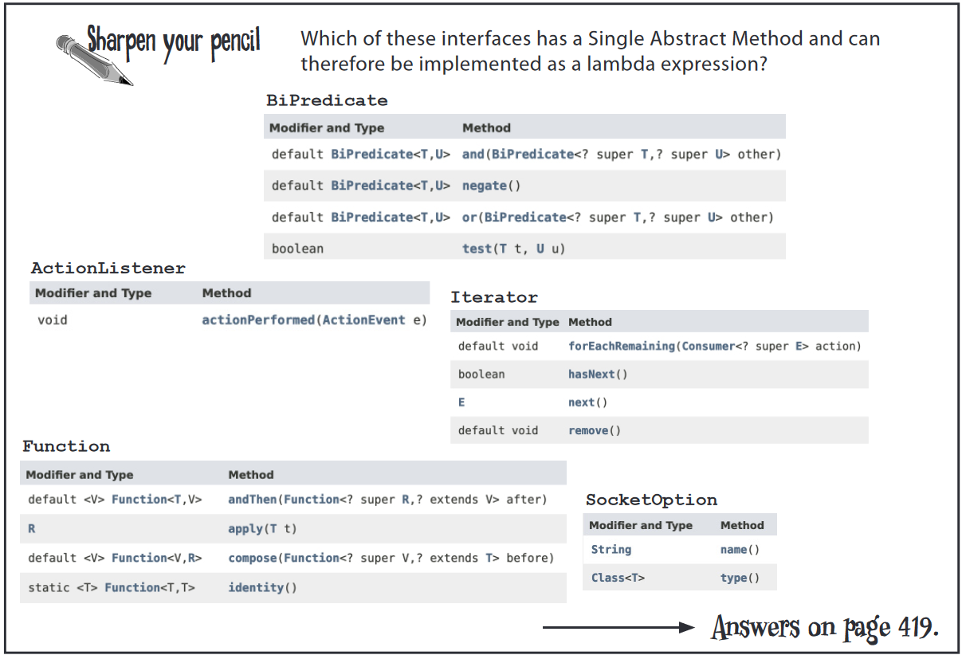

Page(397)

BiPredicate - has SAM

ActionListener - has SAM

Iterator - has 2 abstract method

Function - has SAM

SocketOption - has 2 abstract method